Verify an AR

Step 1:
- Navigate to sso.tamus.edu and select iPayment – Admin Center from the SSO Menu.
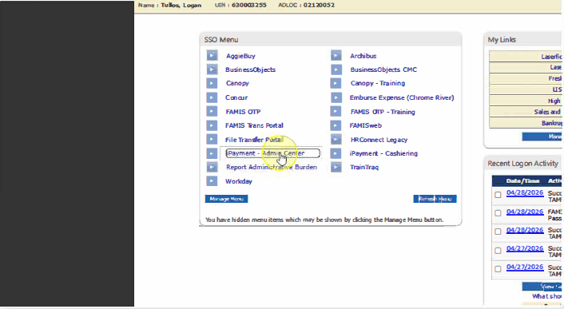

Step 2:
- From the iPayments landing page, select the Search option from the left navigation menu
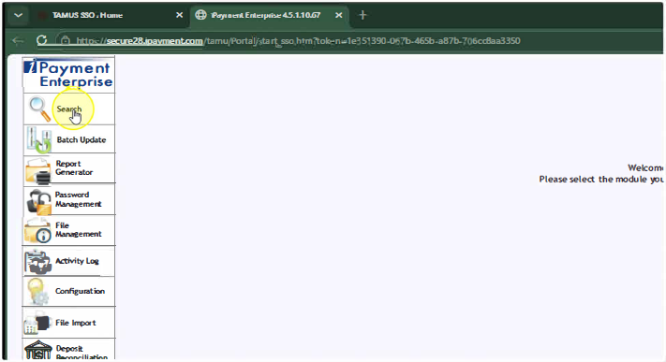

Step 3:
- Select File ID and type in your Core File number 2026…..
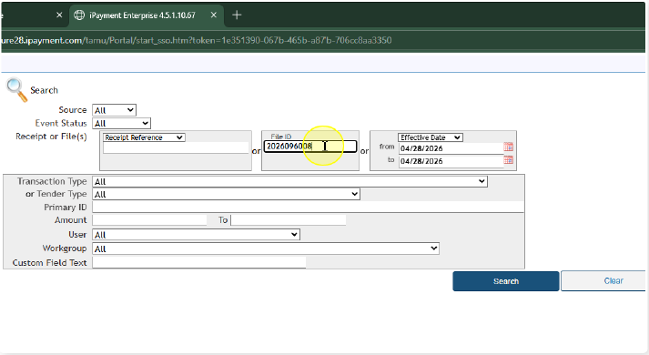

Step 4:
- Select the Search button.
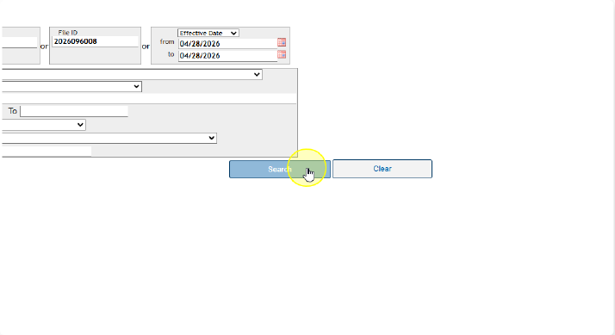

Step 5:
- In the new window that opened, on the left side, select the Blue Reference Number to see the full file. *If there are multiple reference numbers, click each one to find your specific file.
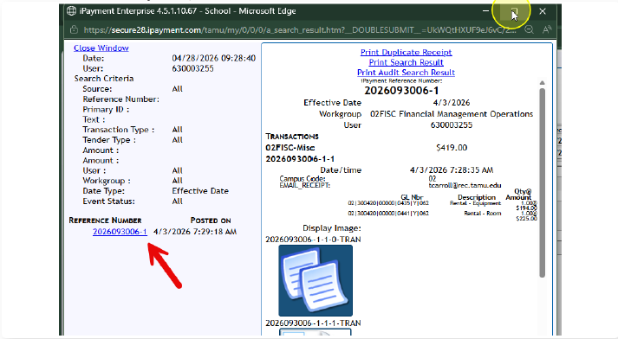

Step 6:
- Select the Reference Number.
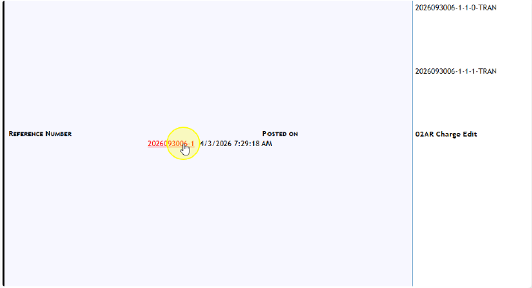

Step 7:
- Locate the invoice number at the bottom of the file.
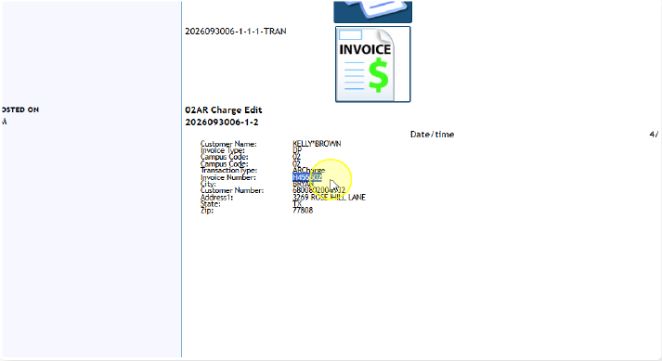

Step 8:
- Launch FAMIS Replatform and navigate to Screen 635.
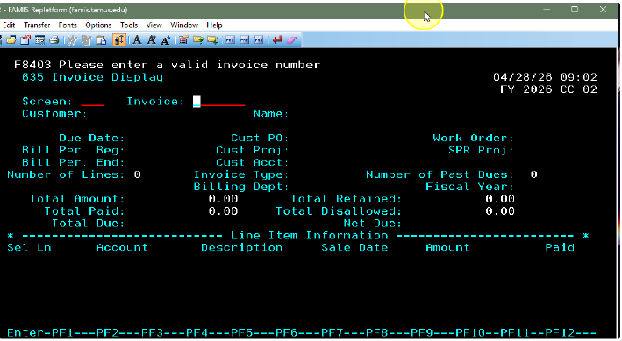

Step 9:
- Type in your invoice number and you will see if it has been posted or not.
