Verify a Deposit

Step 1:
- Navigate to sso.tamus.edu and select iPayment – Admin Center from the SSO Menu.
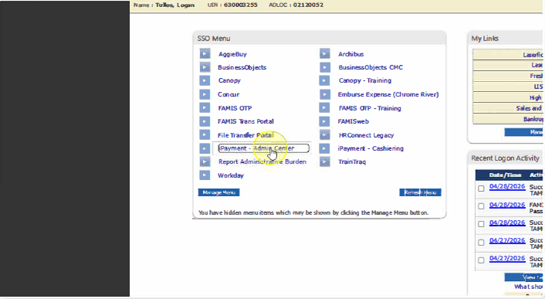

Step 2:
- From the iPayments landing page, select the Search option from the left navigation menu
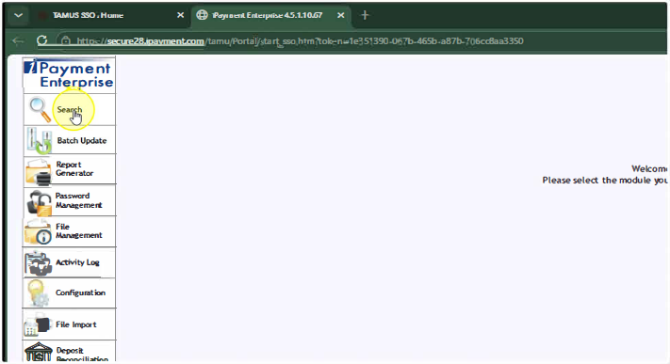

Step 3:
- Select File ID and type in your File Number.
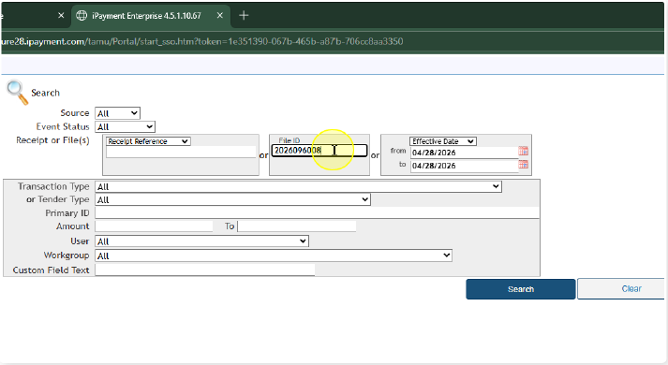

Step 4:
- Select the Search button.
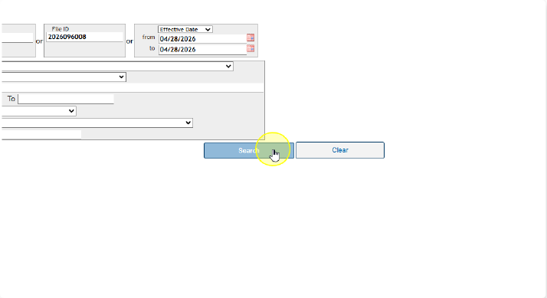

Step 5:
- In the new window that opened, on the left side, select the Blue Reference Number to see the full file
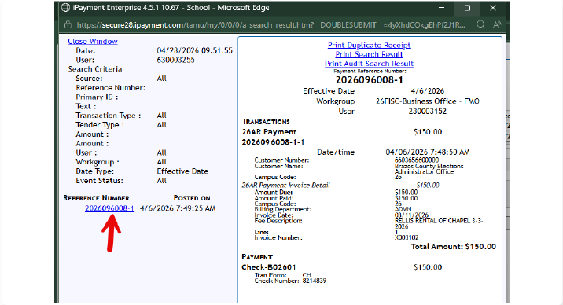

Step 6:
- Locate where the deposit is going. In this case it is going to an Invoice.
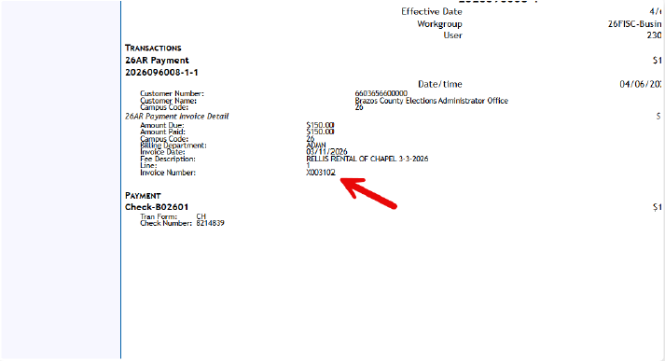

Step 7:
- Launch FAMIS Replatform and navigate to Screen 882 and make sure you are on the correct Active Campus.
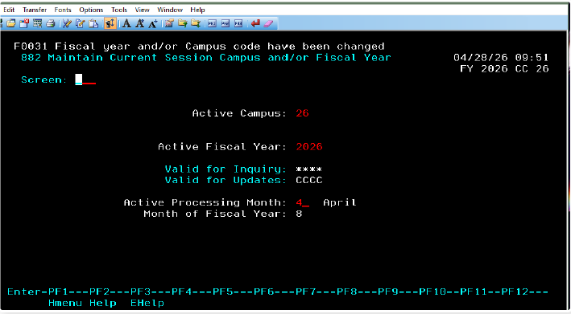

Step 8:
- Navigate to Screen 635 to find the invoice.
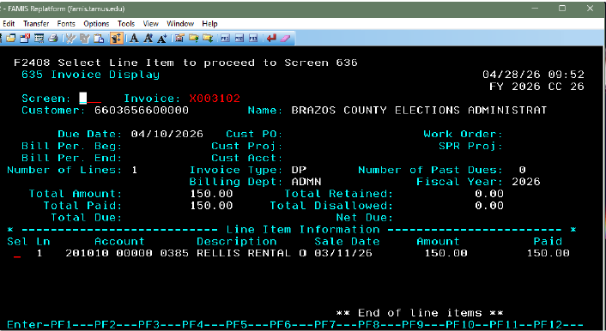

Step 9:
- Navigate to Screen 636 to see the payment. If you need to verify a deposit for an account, you can navigate to Screen 47 and type in the account number and reference number.
